11.Write an R program to read a .csv file and display contents

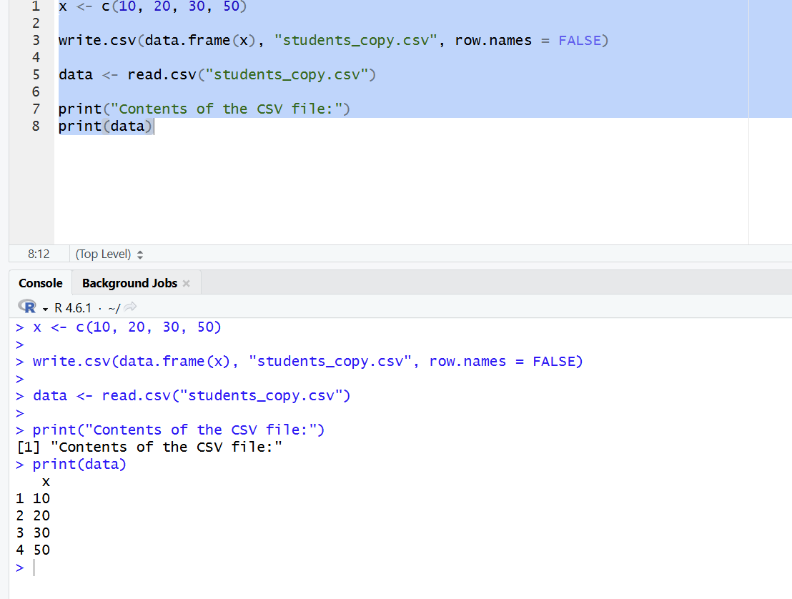

12.Perform data reshaping on air quality dataset: melt, cast, compute monthly averages for Ozone, Solar.R, Wind, and Temperature

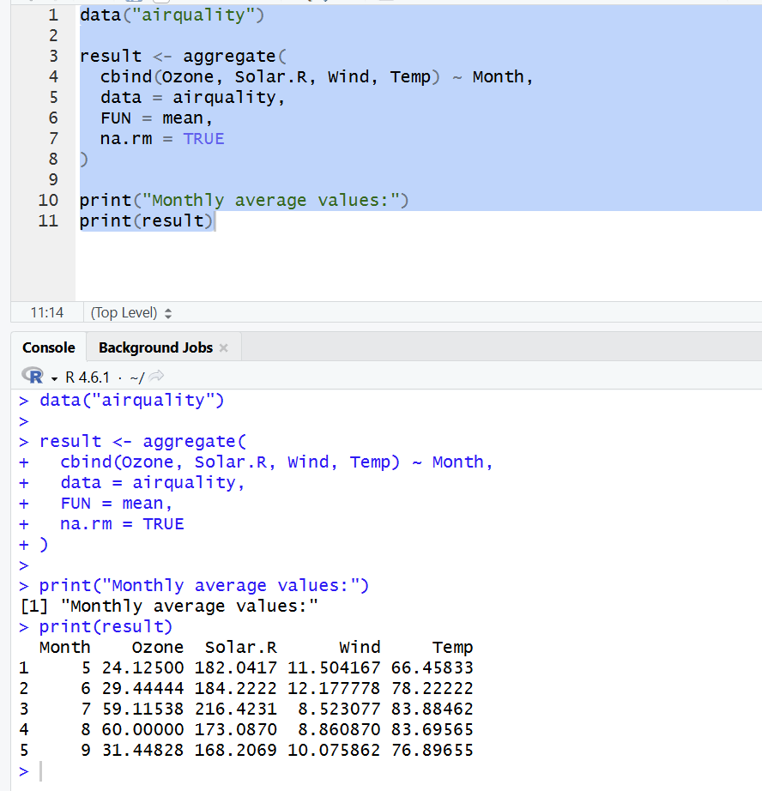

13.Combine multiple arrays row-wise

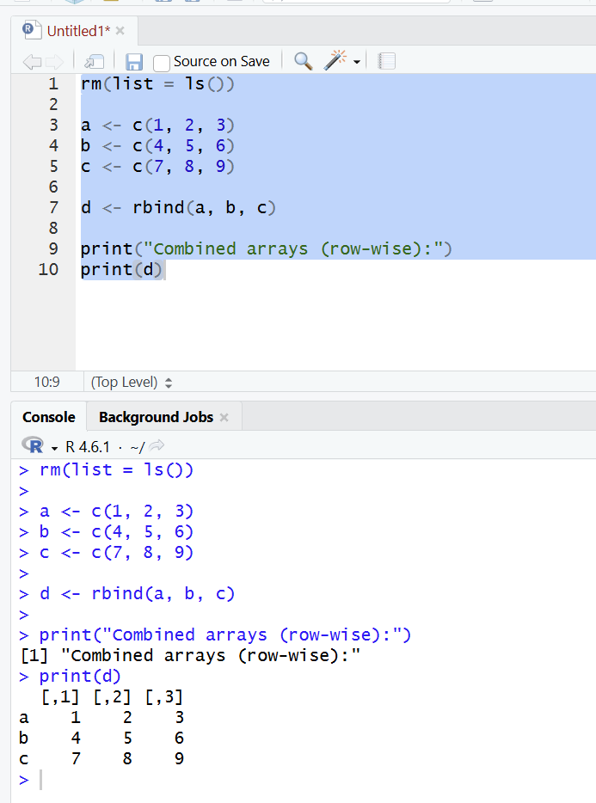

14.Explore and manipulate ChickWeight dataset (sorting, melting, casting by Diet)

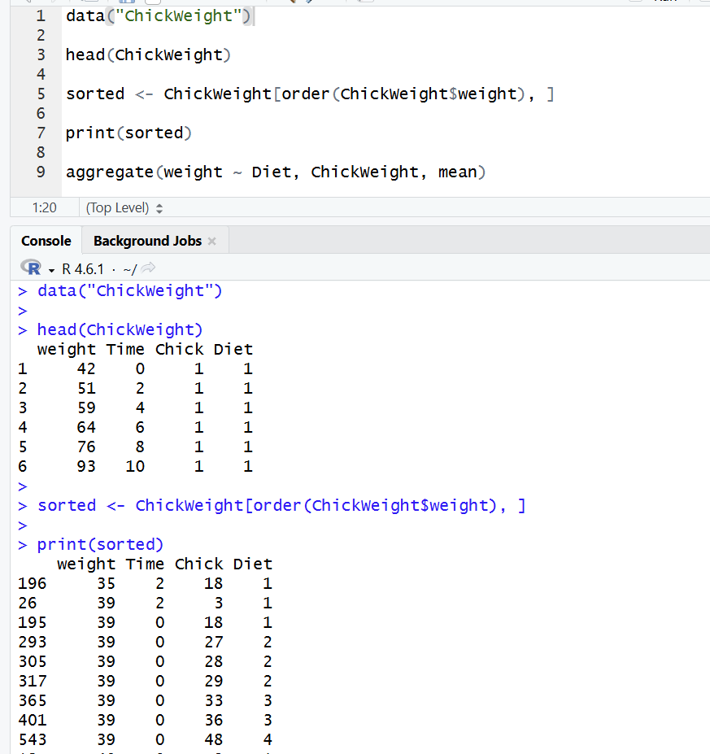

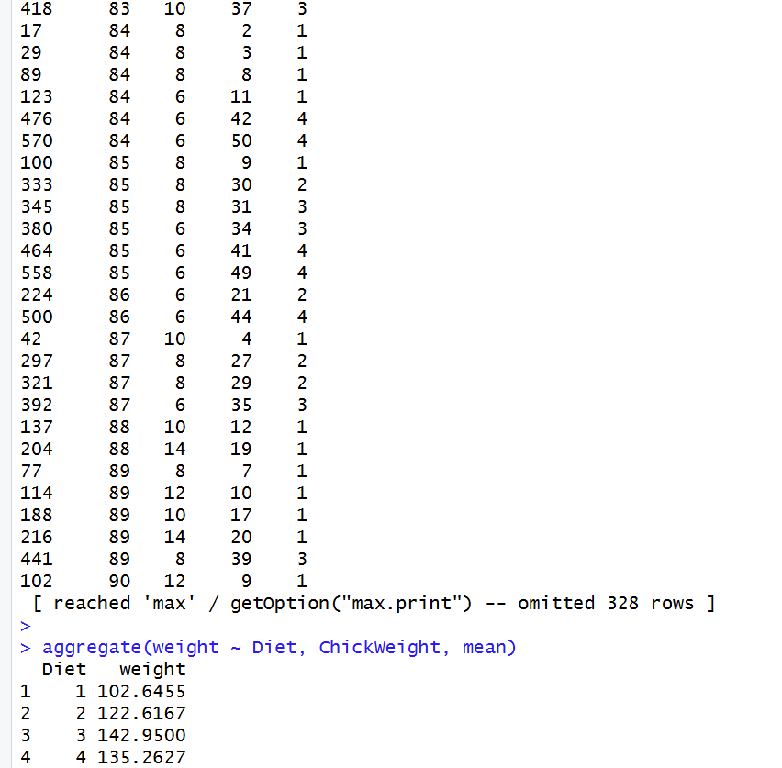

15.Perform EDA on iris dataset: dimensions, summary, standard deviation,quantiles, grouping by Species, pivot table, categorical grouping with Sepal.Length categories

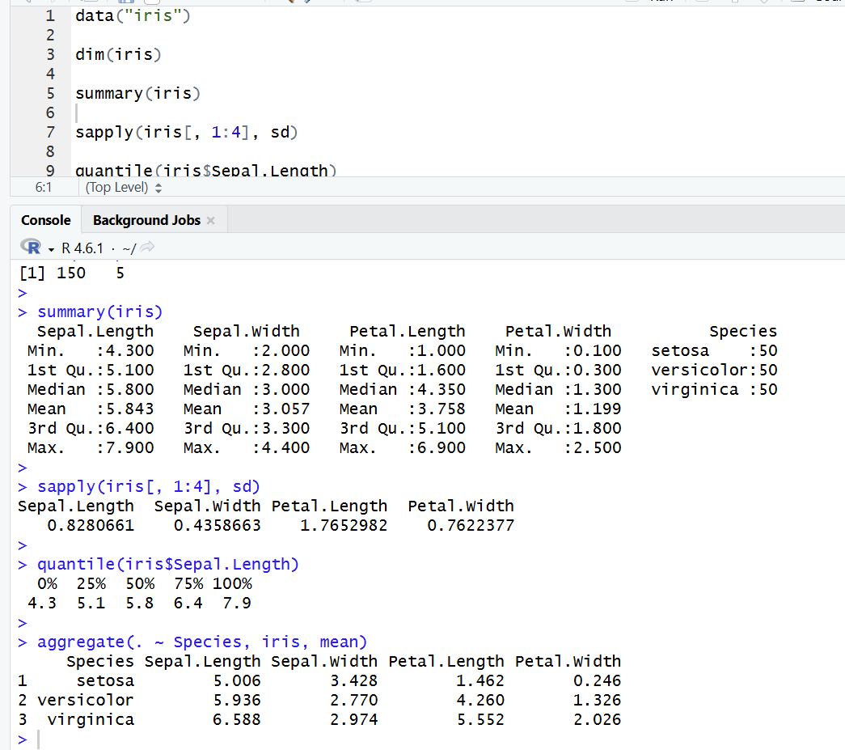

16.Explore USArrests dataset: summary statistics, state with largest rape arrests, max & min murder rates, correlation among features, states above median assault arrests and bottom 25% for murder, visualization with histogram, density, scatterplots, bar graphs

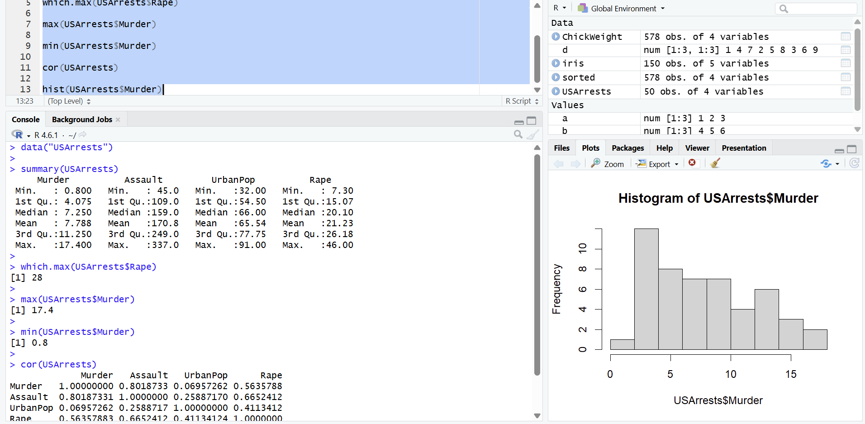

17.Explore Titanic dataset: bar chart of survival vs class, modify plot by gender, histogram of Age
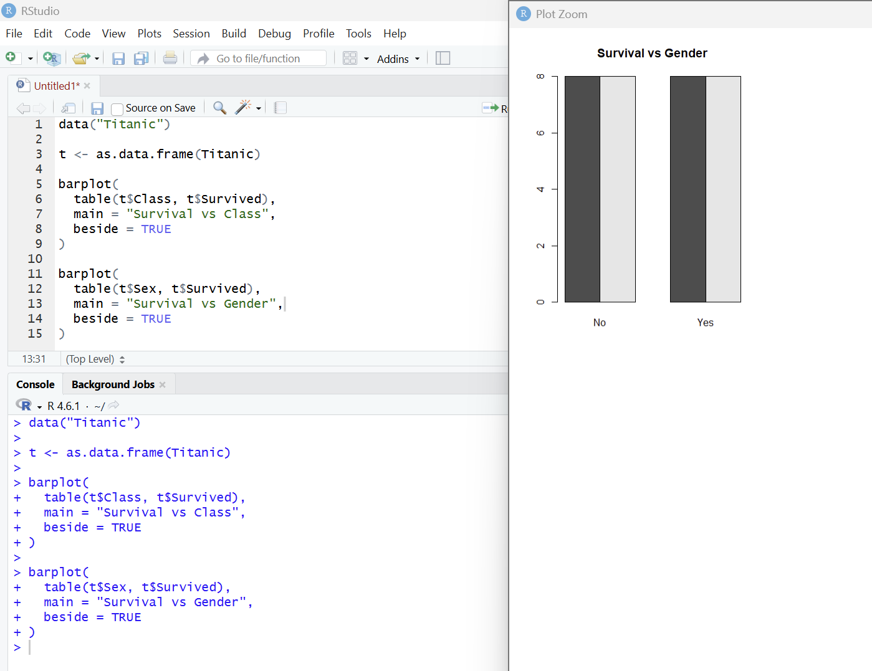
18.Create graphs in R: boxplot, histogram, bar plot, line chart, scatter plot

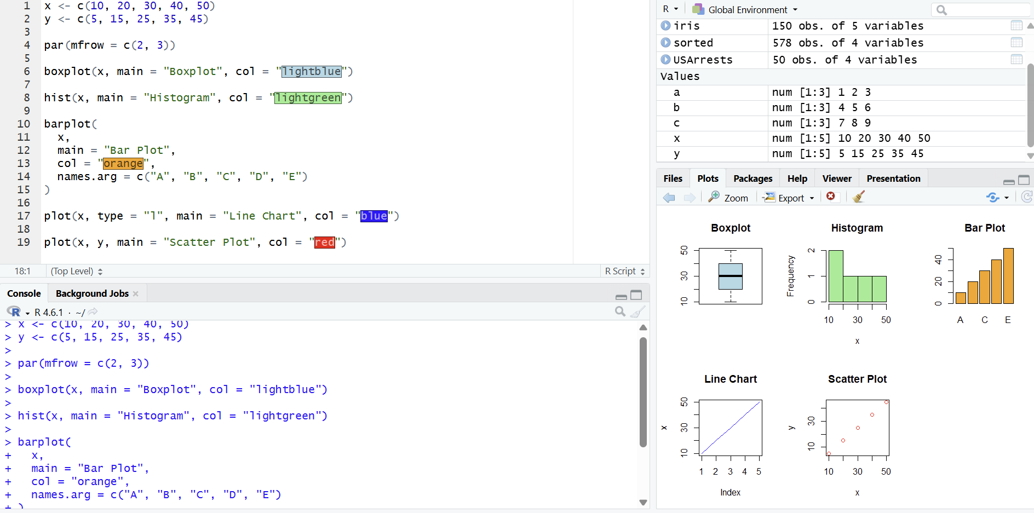

19.Build a regression model on advertising dataset (Sales ~ Spend) and predict Sales
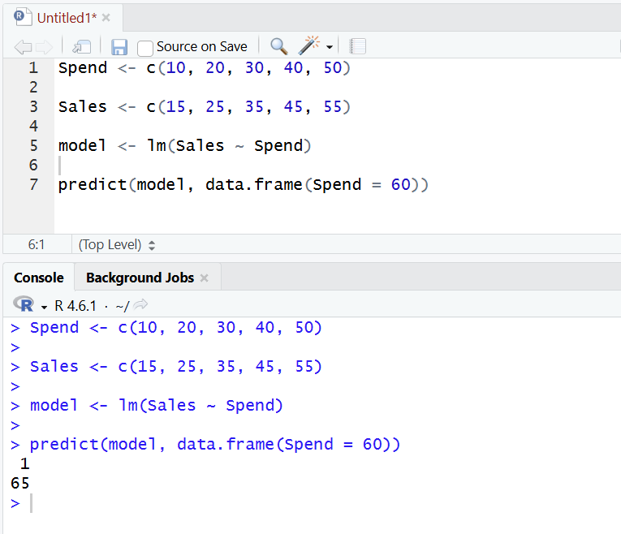

20. Create multiple regression model using ChickWeight dataset with “Time” and “Diet” as predictors; predict weight and compute model error.

